INCORPORATION OF ITIL IN RAINBOW INC.

Zeshan Sayed

Illinois Institute of Technology  
2951 S King Drive  
APT 110  
+16507978341, 60616

Zsayed1@hawk.iit.edu

Anirudh Dutt

Illinois Institute of Technology  
2801 S King Drive  
APT 301  
+13126789518, 60616

adutt2@hawk.iit.edu

Vaishnavi Gondane

Illinois Institute of Technology  
2951 S King Drive  
APT 706  
+13123838814, 60616

vgondane@hawk.iit.edu

**ABSTRACT**

In today’s competitive world, where the organizations are after their sales targets, an individual is hardly worried about maintaining and cleaning the offices, warehouses, or other working areas of that company. Maintaining and repairing are some evident keys for an organization to work smoothly without affecting the mundane. In most cases, these organizations have their internal body of cleaning who are not adept enough to provide the proficient services. Even if they provide the adequate quality of service, they fail to understand every aspect that needs to be covered under their service. This stimulates the idea of outsourcing and creating a federated service which has ease of access and care.

**Keywords**

“SWOT Analysis”, “Service Strategy”, “Service Design”, ”Service Operations”, “Service Transition”, “Continual Service Improvements”.

# INTRODUCTION

In our project, we are analyzing the service strategies of Rainbow Cleaning Specialist Inc. which provides cleaning, maintaining, restoring, and repairing services. Rainbow Cleaning Specialist has expert janitors and high-quality equipment. Their goal is to offer cleaning on a schedule that will work for clients. It consists of web application which is the easiest way for customers to communicate and pursue to the services. Current goals of the company are as follows:

* Creating a more accessible environment for customers.
* Bridging the gap between clients and company by incorporating IT services.
* Expand its services nationwide.
* Demand Management
* Increase profits

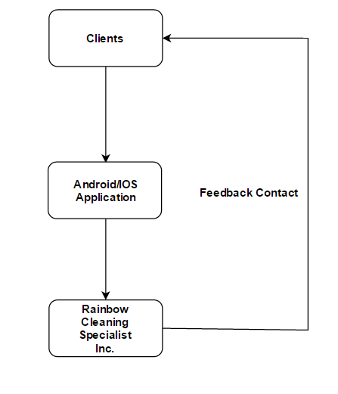

**Figure1. Basic flow chart for design of mobile application.**

We are proposing a distinct ITIL service strategy to achieve Rainbow Inc. their goals. Our suggestions to attain those include

* Introducing customers to wireless mobile services like Android/iOS application for ease of access.
* Providing online chat so that clients can get on demand services.
* Nationwide services can be proliferated by creating awareness on social media like Facebook, twitter, LinkedIn.
* Cost analysis should be done at periodic intervals. Budgeting and Accounting aspects of Financial Management should be monitored. We are suggesting Rainbow Inc. Implement optimized offers and estimates to customers.
* Have a one stop service.

# PROBLEMS

* **No Sign-up or Login**: The website doesn’t contain a sign up or login link so that the customer need not enter the details every time they enter the site. This would help the customers in saving time from entering their details.
* **Categorization of Quick Quite Section:** The quick a quote section could have been made more categorized by including a drop regarding the kind of kind of message that the customer wanted to enter. This would help the organization in categorizing the different kind of concerns and classification that the customers are raising.
* **Only Web Application:** The organization does not contain a mobile application. Every time a customer wants to make a booking, it has to be done through the web application. Creating a mobile application would ease the process for the customers so that could easily make a booking for a service like “book on the go” option.
* **No on the Spot Chat Services:** It could be made more compatible by creating an online chat services so that customers could clarify their concern. Online chat services would help customers in getting their doubts and concerns sorted then and there rather than dropping a message to the organization and waiting until they get a response. This would help the company to attract many more customers.
* **Online Payment Service:** The organization does not contain an online payment services where they could make a payment through a gateway service. This is an extra hindrance to the customer where the payment has to be done through a different mode. Instead if an online payment service is created, it would help the customers to ease the flow to make a payment simultaneously when booking for a service.
* **Better User Interactive:** The website could be made more user interactive and user friendly by making the UI and other features in web page more interactive and ergonomic.

## SWOT Analysis

* **Strength:**With the advent of the concept of ‘Clean and Green’ and countries promoting sanitization, the rise in the number of people willing to maintain their surroundings has increased. Also, number of people taking to ad hoc services has seen a rise. These advancements call for an aid to ease this process. Similarly, with the increasing competition between service providers from the same industry calls for the need to provide a comparison for the selection of the best.
* **Weaknesses**The application runs on internet. It cannot be used in the regions where there is poor or no connectivity. With poor connectivity, the performance of the application would drop. Adoption of the application needs thorough analysis. Thus, its popularity and frequency of utility needs to be enhanced.
* **Opportunities**It finds a place in developed cities with people who are aware of such kind of services; in cities known for its educational institution and cities that attract large number of immigrants. The target would be to provide service during the peak hours of occupancy – for restaurants, gas stations, parking lots etc.
* **Threats**Several companies offer applications that cater to a specific service – such as maintenance. These provide more elaborate features and choices. Users are very picky about it and might choose to take to these applications over the services of Rainbow Solutions.

# SERVICE STRATEGY – Rohan Shirke

IT Service Strategy for Rainbow Cleaning Inc. is to make sure that the Firm should be able to handle all the services that are been defined in the service portfolio, and are always in a position that they should be able to satisfactory service for their customers and make the life of the their customers very easy so that they can focus on their actual business and don’t have to worry about the allied tasks like maintaining and cleaning the places in their offices, homes, corporate parties etc. which ultimately helps them to increase the profitability of their actual business and make the business more efficient so that they can compete with the cutting edge competitions in today’s dynamic world. However, the prominent processes of Service Strategy are Demand Management, Service Portfolio and Financial Management.

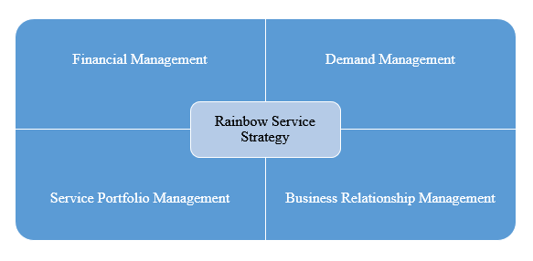

Figure 2. Service Strategy:

## Finance Management

Finance Management: The finance management of Rainbow Cleaning Inc. consists of two departments the fund-raising team and IT auditing team. Since the Rainbow Inc. is a startup company and is trying to put a mark in the industry and in this specific domain, it is very important for the team to meet with different ventures for capital gathering and they have to convince various organizations to provide the service and expand the business in the market. The teams will basically validate the expenses and will quantify the budget and will do the strategy to increase the profitability of the organization.

### Fund-raising

The Fund-raising team is the most important team which will bring the business and the funds for the corporation. This team will meet to various venture capitalists and will present them the business objective and the need in the industry and accordingly will present the strategy of our business by which the venture capitalists will invest in our organization for our present and future funds. There is also a team called business development team which also does the similar kind of task but they will raise the fund by cracking various deals with various clients where they will meet with the customers and get the projects. The Rainbow Inc. finance team divides the annual year into 4 quarters as how the corporates are being divided in to 4 quarters which helps to keep the accountability of the organization and strategize as what steps needs to be taken to improve the quality of the business. The team strategize themselves to various factors in the market like the Rainbow gets the maximum projects during the last months of the year as lots of people enjoy and lots of events happens or during the summer when lots of things happens in alacrity. Hence, we can specify few months as slack period or busy times by which we can strategize and by analyzing the previous data, we can be better prepared for the betterment of the organization. The Rainbow organization conducts regular meetings with the stake holders and with the strategy team to improve the performance of the organization.

### IT Auditing Team

Since the Rainbow Cleaning Inc. is a startup, The IT auditing team of Rainbow don’t have a predefined standard process in their IT auditing team and they need to setup the process. Right now, if they need to deploy the application on a new server they don’t have a proper process of commissioning a server and they don’t have a specific security policies in placed by which the vulnerabilities in the IT security will exposed and the service can anytime be compromised from the hacker. Hence, we ensured that the security policies are being placed. They also take care of the expenses which gets incurred for the commissioning and decommissioning of the servers. Currently they have web applications in place and the load is not so much and they are currently serving for only few locations in USA. However, they are planning to go across many places and spread out the word by extending the services to lots of customer all over USA but that requires proper ITIL processes in place. They don’t have a process for approving the requests whenever they need to commission any server in need or any hardware in need which incurs cost and those costs don’t get accountable many a times. Due to this, many at times it happens that the unnecessary cost of the hardware or of the service gets increased. This process needs to get repaired quickly so that the audit team will prepare a full year financial report and that could be very well presented to the investors whenever in need and will provide a transparency of financial transactions to the higher management of the organization.

## Demand Management

Currently, the Rainbow Cleaning Inc. team is performing fine but not as compared to the market or not as they want the company should grow and hence we tried to figure out the demand management for this kind of service and how we can scale this particular service into the market. The Cleaning service is very prominent right now for lots of organization where they don’t have to worry about their maintenance activity and the organization can very well focus on their prime services. Since the application is right now hosted only as a web application and they don’t have a proper infrastructure to go it on mobile world. We have approached them and provided them the solution to go them on mobile since almost everyone is using the mobility service currently which can be easily accessed at any point of time right from your palm. You don’t have to login to your computer to access a service and request for the same.

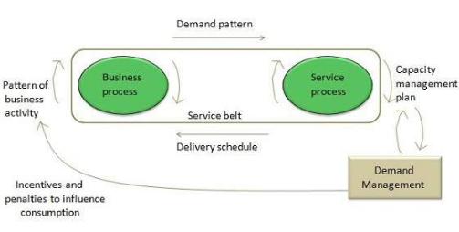

Figure 3. Demand Management:

Demand for Cleaning Inc Service: In today’s competitive world the organizations don’t have much time to build all the processes on their own for each domain whereas they usually outsource it and that makes it interesting and creates a lot of opportunity to expand in current world.  This business wants to grow very rapidly and now they need to get into the market as soon as possible and hence to maintain the services like cleaning and maintaining the offices or their apartment, there is a huge demand which needs to be fulfilled in a proper manner. We have provided a solution to go them on mobile and also in their existing setup, the web application doesn’t have the chat application which basically increases the inclination and user experience to connect it to the customer personally onto web application and that way this would be a tremendous need for the service to flourish. The service satisfaction survey or the monitoring tool needs to be in placed so that the data extracted from that surveys or those tools will help us to analyze to increase and gauge the performance of the service.

## Service Portfolio Management

* To grow the business in the market, we have proposed following services which needs to be implemented by the Rainbow Cleaning Inc.
* Implement a proper ITIL Service processes which basically place a approving process and have a proper hierarchy for commissioning and de-commissioning of the hardware and the infrastructure tools so that proper accountability be placed and to reduce the redundancy when there will be an increase in the size of the organization which ultimately reduce the costs and maintenance of the organization.
* Providing a mobile app solution for increasing the reachability and accessibility for the users and customers and making the application more popular.
* Implementing a Chat Service for their current web application which will make the application more interactive and increase the user experience of the experience. To increase the popularity and usability, the application needs to have a good user experience and customer satisfaction service and the accessibility of the customer support to make the service satisfactory.
* Extend the market of the Service by implementing and provide the service all over the nation.
* Creating awareness of the service through social media by proliferating the viewership of the users by sharing the same through Facebook, Twitter etc.

## Business Relationship Management

### Customer Satisfaction Survey

The corporation will do the survey to find out the satisfactory performance and review the service by Rainbow Cleaning Inc.

### The Complaint Box

The user’s complaint needs to be gathered and should be processed from a proper channel to mitigate it. The chat box in the application will help us to deliver the solution of the problems in the fastest way and that will ultimately increase the customer satisfaction for the service at Rainbow Cleaning Inc.

# SERVICE DESIGN - Anirudh Dutt

The service design is the depiction that secures hopeful arrangement entangling the recommendation, working and contribution of individuals, sorting out and proposing the unique situations, cleverness of an administration with the point of composing the qualities and the collaboration betwixt the specialist organization and the end clients. On the advancement of the arrangement, the arrangement is then sent to the administration move phase of the life cycle to discover, manufacture, ask and use the generous or the changed administrations. Thus, with this simple definition of service design, we propose a design that fulfills our aim to build a wireless mobile service on Android/iOS platforms.

In this stage, we would go for creating and planning a utilitarian administration which is not done in segregation but rather is additionally expected to imagine the dynamism on the exhaustive administrations, the regulatory body, the foundation, the data innovation world, the procedures and all the essential examination. The main purpose of building a mobile application is to provide an ease to customers so as they can opt for the services anytime using their mobile phones and clicking on the services listed. In order to achieve our target, we have to firstly consider the User Interface (UI) of out mobile application it should be such that it is easy to use and the maintenance factors such as bringing an update to the application and bug fixtures are minimal to make sure that the actual cost of project doesn’t exceed the budget passed for our proposal.

The Application would not only make it easy for the customers to opt for the services, but it would also provide a media where the customers could easily chat with the customer representatives to solve the issues if they faced any. This, would make a transparent relation with customers and company where the customers can rely on the company for the services they have opted for. This single step will in turn increase the business for company where they can expand their business nationwide as the Mobile Application will be available on Google Play Stores and Apple App Store from where the customers can easily download the application and use the services. Of course, if the business expands nationwide then it will automatically increase the profits for Rainbow Cleaning Inc. there will be more customers who will be opting for the service than the current scenario.

To achieve our goal, we need to follow the Steps of Service Design which includes the following factors as mentioned below:

## Risk Management

In this stage of the outline we tend to explore, guess, control and direct all sort of dangers that might be related with the administrations hence composed. This includes the juxtaposition of the considerable number of estimations of resources for the framework, deciding the dangers to those advantages, and making sense of how defenseless every benefit is to those dangers. In this venture, the dangers that we may watch is the system issues which may include the impedance of the information into the air, surrenders in the Operating System bit code or the merchant provided framework code, alternate applications with malignant and helpless code may have admittance to the information of the clients. This is a vital step while we design our Mobile Application it might be available to all the users over the Play Store and App Store services but reaching out to the customers in remote places might not be possible every time as there are places where Rainbow Cleaning Inc. might not cover into their service area and getting the services to those customers might be very difficult. To minimize this kind of risk we can add a section for Sign Up where the customers will fill up the details of their house or office location and if those locations are not under service area for the company the auto pop-up message will occur stating that the location entered is not covered by the organization.

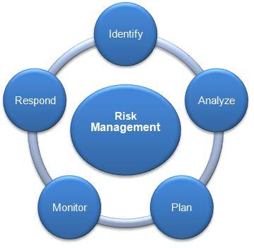

**Figure 4. Risk Management for Rainbow Inc.**

Another kind of Risk in developing this Application might be under chatting settings where some people who are not able to speak English will be unable to provide their query efficiently. Under such scenario, we can advise the developing team to provide a translator so that the language typed by the customers will be automatically translated to English and will be available to the customer Representative attending that problem.

## Availability Management

It is this phase of outline where we decide, break down the arrangements, we measure and upgrade all the air of accessibility of all administrations. This stage is legitimate for securing that every one of the administrations, system, forms, instruments, and so on are applicable and appropriate for the recognized targets. Therefore, with this we can affirm that in the ready administration we continue informing the client in the matter of what are the spots that he/she may visit contingent on their prerequisites that they may have given, this makes the occupation of the client less demanding as it rapidly looks on what might interest for the client and tells them with the points of interest.

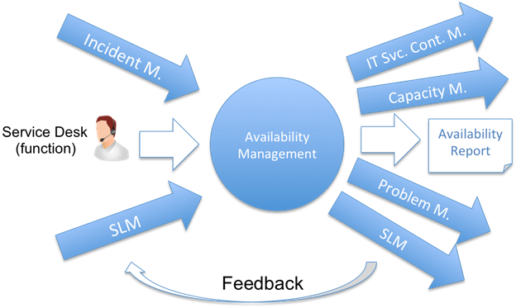

**Figure 5. Availability Management in Rainbow Cleaning Solutions**

In our proposal, we are going to offer an Application to the customers so that they can get the services with an ease without logging into the website of Rainbow Cleaning Inc. which might be a tedious work in some cases. Now under availability management we can take the steps like providing the pop up adds on various platforms such as Facebook, Twitter, etc. if ever the customer has searched for services on internet. Also, over the application we can provide a recommendation system where the user will be notified with the top services he/she has already opted for before. This will increase the business for the company as the frequent notification will keep the customers alert about the cleaning services they have opted for and will make them to opt for the service again if they need it.

Moreover, we can provide a facility where the notification system will not only notify about the services the customers have opted for but also provide the alerts with new updates on the App and will acknowledge the clients with the benefits they can get from these new updates on the App.

# SERVICE TRANSITION – Vaishnavi G

The design phase has suggested some solutions for the company to achieve their current goals. The transition phase will ensure that all the changes and designs suggested are properly translated into the business language and incorporated smoothly into the services. The new services should not hamper the working of current services. It enables and ensures the smooth deployment of the proposed changes to the system. Updates and changes are a part of continuous improvement strategy and it is through service transition we ensure that the current system is not hampered due to the latest updates

## Release and Deployment Management

Android applications receive innumerable updates and humungous number of changes are added to the interface. The target of release and deployment management is to manufacture, test and send the administrations as indicated by the plan characterized in ITSM benefit outline. The release is another arrangement thing which is to be sent underway and a discharge bundle is an arrangement of discharge units. The releases can be a huge explosion or push-pull sort of releases.

Enormous detonation release implies a change is conveyed to all clients at the same time. It is for the most part utilized when there is a procedure change over the entire association. Push sort is the place the part is conveyed at one focus and afterward conveyed to different areas. Pull sort is the place the clients can download the product to their areas and get to it.

To increase the user accessibility, we are suggesting Rainbow Inc. to introduce an android application. The release packets in android are deployed without affecting the normal services already in place. The releases are conveyed as required in little parts. The exercises incorporated into discharge and sending are arranging, aggregation, building and testing, making pilot models, appraisal, check, audit and early support. This will also include the files such as readme files where we will explain the customers about the product and what are the advantages they can get from the product that we offer.

Apart from the release there are prerequisites such as testing where we test our product on a larger scale so as to assure that the final version that we release to the users has no bug or if it has the occurrence of it is on a minimal level. The other thing that we need to make sure is that the application that we are developing provides a one stop service to our customers i.e. a customer gets his/her solution from the mobile application itself and he/she doesn’t have to login to the website to opt for the services.

The Service V-model is utilized to demonstrate the eliminated discharges and the testing which happens on each level of the setup. It takes after waterfall lifecycle yet can be utilized with different models also. The correct side of the model demonstrates all the test and approval things which are required for the individual exercises specified on the left side. For instance, the above V-model is a general venture which has specialized and utilitarian prerequisites. At each phase of the model, the test methodology is taken after. Test technique characterizes an approach for unit testing, incorporated and robotized testing. Approval of information is likewise done at each arrangement level and in each condition like Test, UAT, and Production. It needs to go in each condition.

The Service V model as shown in the figure describes the following process that can be applied to our proposal as well:

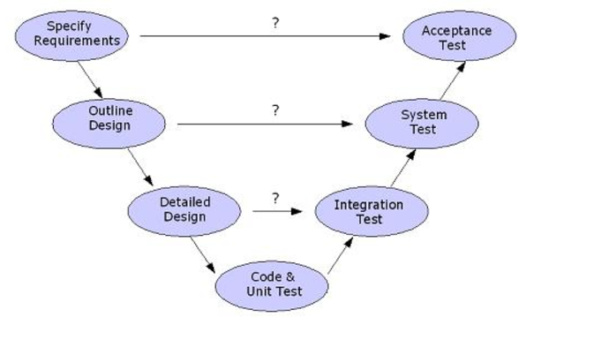

**Figure 6. Service V-model**

* Specify Requirements: Here we need to understand the requirements that a customer needs from this mobile application. We need to consider all the services that Rainbow Inc. offers over the website and we need to include all those into our mobile application so that the customer is satisfied with what we offer.
* Outline Design: The outline design is the UI of the application it should be easy to use and user friendly.
* Detailed Design: The detailed design is the exact design of the application which includes the database design the structure of operation or the operational flow of the application.
* Code and Test: This can be said one of the final stages of release and deployment management where we test our application on a device and check to see if any misbehavior of the application is recorded or not.
* Integration Test: Under this scenario we will test our application on a larger scale where we will check the robustness of the product that if it is easy to use on other platforms and devices or not.
* System Test: This is the second last procedure of Release and Deployment management where we test our system for the final time before releasing it to our customers.
* Acceptance Test: Once all the above tests have been run successfully, we would have to wait for the approval from management level so that we can finalize the product and deploy it to our customers.

## Change Management

Change Management can be applied to our goals where we are proposing the company to build up a mobile application through which the customers are able to easily access the services. There are inevitable changes that come along everyday it may be an update in Android OS or something like that under such scenario the company must make some changes to their Mobile Application so that the customers who have updated their devices are also able to use the application easily. Changes emerge in ordinary IT applications for varied reasons and advantages, for example, the business association is enhancing administrations or expanding the benefits. These progressions are for cost adequacy or making the application more technically knowledgeable or easy to understand. There are responsive changes too which are made after the arrival of introductory item which manages settling the blunders and issues. The motivation behind practical or specialized changes is to institutionalize the procedure, decrease the dangers and build up an ideal approach to deal with solicitations.

The key factor of change management is to make the changes to the current IT services without disturbing the current ongoing services that are currently available for use. This means the older version of the software should be available for use while we develop the newer version with minimal or majority changes. Therefore, we need to guide the developing team so as to keep the older version live while the newer version is not developed. Moreover, there are some customers who have been using old devices of their mobile phones which do not support the latest updated version under such cases we must also consider the older application to be live and working so as not to lose those customers with older devices.

The above-mentioned points were related to the technical staff where we are majorly focusing on the development and changes in the mobile Application that we develop but apart from that we also need to make sure that the expenses to achieve these changes does not exceed the actual budget passed for the project. The daily changes will not only help to build a new and more robust UI for the customer but will also have an impact on pulling new customers into our business. This can be seen from the example of amazon.com where they have their entire business on internet the friendly UI of Mobile application and daily updates on the same not only supports the services for business but also supports the facilities such as pop-up ads on other websites which advertises the products to the customers that they might be interested and in turn increases the business to expand more to the other customers this fulfills our target number 3 where we have suggested to give ads on other websites such as Facebook, LinkedIn, Twitter, etc.

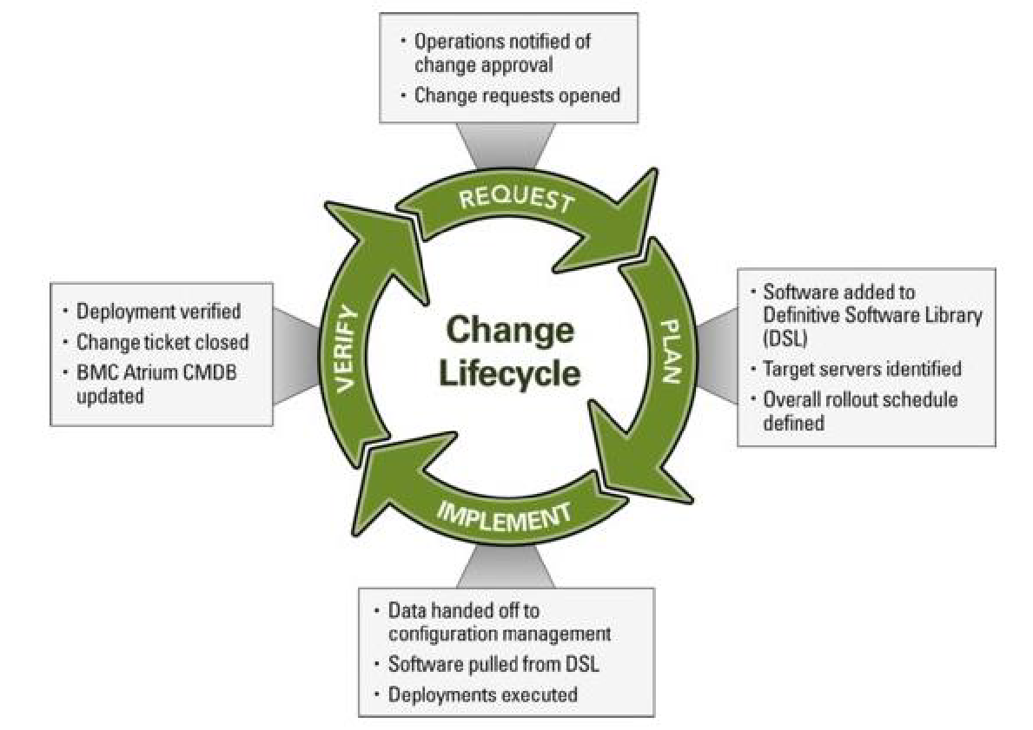

**Figure 7. The Change Management Lifecycle**

Under change management process we need to consider the following points for making changes in our proposal if any needed:

### Standard Change

Under this step, we can say that the operational changes such as regular update of application and adding recent changes and facility to the application are to be considered. Changes which are the pre-endorsed operational changes and are regularly for between related administrations inside the IT association.

### Normal Change

Typical changes are those that follow full way the procedure and are normally started through RFC and assessed by change advisory board (CAB).  These are the changes that we will be proposing when the project is approved by the board and these are periodic changes that will occur unaware of the fact that are these really needed or not these changes are defined on management level and will be implied when it is scheduled to occur.

### Emergency Change

Emergency changes are those that are actualized in a period delicate way. These progressions anticipate potential disappointment, need or loss of usefulness or need or loss of income. This is a live service that we are offering and there are likely some circumstances that it might fail somewhere so considering this fact our team should be responding enough to handle such failures and make the changes accordingly so that the business does not suffer any loss.

### Change Priority

The priority of change is determined by the urgency and impact of change. These changes can be considered where if our application misbehaves in any way in-spite of the prior testing, then the management team should be ready enough to prioritize those problems and make the change management hierarchy accordingly so that the changes that need to be done first are attended first.

# IT SERVICE OPERATION–Zeshan Sayed

The objective of Service Operation phase is bringing the proposed objectives in to action. It maintains satisfaction in a business by delivering effective and organized IT services. It reduces the risk of service outages on daily. It scrutinizes that the IT services are provided to the authorized and authentic users. It takes input from Service Transition as the early life support and gives service performance reports as the output to the CSI

## Goals of Service Operation

All the services proposed in service catalogue will be delivered effectively. The requirements are taken in to consideration and deployed, for example the proposal of bridging the gap between client and services is been completed by deploying the android application in the real-time environment i.e. on android platform for the clients to download it and use the appropriate services. The requirement of improving user interaction will be fulfilled with the incorporation of human machine interface in the application itself. The efficient demand management will be handled by improving customer service on both apps which was initially handled by the web app only.

## Scope of Service Operation

The objective of making organization nationwide will be handled by increasing the manpower and continued in continual service improvement to increase the business respectively. The results of all the processes will be given as an output to Continual Service Operation.

## Event Management

The main objective of event management is to detect an event, make sense to it and determine control action for it.

The increase in demand will result in to increase of requesting services and increase in requesting services will trigger increase in man power. These small events should be taken in to consideration as they form the basis in CSI further. Also in here the services that are promised to the customers are checked with the actual services that are deployed it means the application interface along with it human machine features will be tested with service level agreement. If suppose customers are not happy with the GUI, it will be reported in to one of the three events that are informational event and given to CSI for improvement process.

### Categories of Events

The categories of events are as follows: -

#### Informational event

Informational event can be explained as suppose the customer are not harmonious with the application interface and they are finding it difficult to understand it. The problems in application events can be its complexity i.e. it is not easy to understand or colors are not soothing the eye. This can be a mere simple example of the informational event. These types of problems can be reported to the front-end developers of the application development team to resolve the issues facing by the customer.

#### Warning Event

In case if few customers are not able download update information on the service portal. For examples, blackboard portal was suffering same issue, in which students we not able to upload documents when they were using Chrome application designed by Google. These types of problems are concluded as warning events. These issues can be reported to the availability manager who is responsible for solving and improving services to the customers. These warnings will be stored in reports, to refer if incase similar error occurs in future.

#### Exception Event

Exception event is major event which effects the availability and impacts the business to a great extent. In case if the server is down and no one can obtain the services. This is the major breakdown and thus needs to be reviewed and solved as soon as possible. This problem can be solved by replicating services on different servers and having a backup of the services so that no data is lost when major breakdown occurs. Once the replications and backup are created, then even if major breakdown occurs, the replica of the main server can supply the availability of services.

## Incident Management

It makes sure that all the components of the services are working harmoniously. Incident management minimizes these problems and ensures that the service operation continues without any problem and if an incident occurs then how will it restore the services to make them work properly. If a server breakdown occurs in the system, then no service will be online thus making it difficult for customers to use the services. Thus, in this case the Rainbow Organization can replicate database on different servers so that it can be used during services outages. If suppose this event is present in reports then suitable methods can be used to handle and mitigate the incident in future.

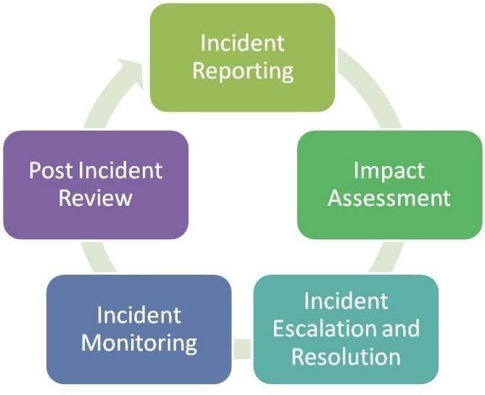

**Fig 8. Incident Management**

* **Incident Reporting:** It includes tasks when the incident or the breakdown happens. If suppose due to increase in demand there in no man power available, such incident should be handled appropriately as no man power means no services available to give to the customers.
* **Impact Assessment:** It includes scrutinizing the incident, for example if the incident has occurred before or it is a new different incident. For suppose, if the system has problems in authentication, then the how was the problem solved, these steps will be taken in to consideration, which helps analyzing incidents.
* **Incident Resolution**: It includes solving the problem by analyzing the incident and correcting it.
* **Incident Monitoring:** Once the incident is resolved, for suppose authentication, then the whole process of authentication login is analyzed and monitored for reporting why exactly it occurred.
* **Post Incident Review:** It includes review of

# CONTINUAL SERVICE IMPROVEMENT- SreeKumar Selvam

Continual service improvement is the process where it uses technique which learns from the saved history. Continual Service Improvement (CSI) uses an estimation driven approach to manage recognizing open entryways for advancement and to gage the impact of progress attempts.

The principle point of any industry and especially IT is to give items/administrations fulfilling client necessities. Keeping in mind the end goal to guarantee quality, persistent administration changes an imperative piece of ITIL is basic to audit, investigate and guarantee that there is constant change in the administration. CSI depends on the straightforward idea of Plan, Do, Check and Act. As we know arranging is imperative to continue in an orderly way. Once the arrangement is set we should take after the means, then check and dissect the information and take activities to actualize the progressions.

If CSI is having out its impact truly, there will be change suggestions rising out of all parts of organization movement. The affiliation is most likely not going to have enough resources for complete most of the proposals, so it is imperative to get the change openings, fathom their impact, degree, and resource necessities, and compose their use. CSI uses the CSI enroll as a gadget to record, look at, and prepare for improvements.

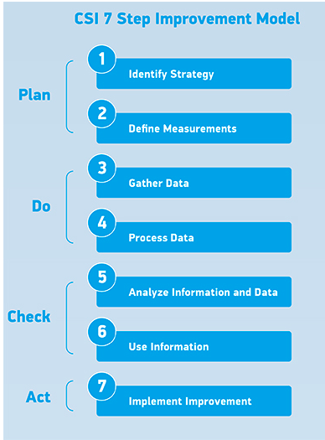

**Fig 9. CSI Model**

Rainbow services has designed the metrics in such a way that they offer excellent services to the customer. We have planned to design a mobile application on iOS and android devices so that the customers could book the services offered by the company on the go there by making it more customer friendly and would help to attract more customers. In addition to the mobile application creation, the application would also provide numerous services to the organization like providing them timely notification or messages about the booking reference number and the status, and other services like the arrival of the employees and the start and end of services. They would also be getting messages regarding the cost of the services so that the customers need not check the online every time for the updates and the notification. This could help the customers to get to know about the time of services happening and the timely updates on their mobile. Despite the way that CSI is a time of the lifecycle and is accounted for in an alternate ITIL generation, CSI can be effective just in case it is composed all through the lifecycle, rolling out a culture of interminable improvement. Also, the customer could be including their ratings, reviews or complaints through their mobile application instead of directly going to the desktop application or through various social media platforms like Facebook etc. This could also help a lot in retaining the existing customers and also through these factor, the company could also attract other potential customers.

The organization maintains a database where they could retain the feedback about the employee from the customers about their services. They could extend their services to the janitors and other employees who are involved in their company in order to retain them. This could be done by providing more employee benefits like health insurance benefits and travel allowances to the customer apart from the monthly salary. They could also be provided with certain tri-monthly bonuses based on the customer ratings upon them. These benefits to the customer could be done based on ratings that are given by the customer and then tracking them down on a weekly basis.

A key task for CSI is to recognize which estimations out of the thousands that are made step by step should be watched. This is done by recognizing, for every organization or process, what the Critical Success Factors (CSFs) are. CSFs must be accessible if a technique or organization is to succeed. Apart from these, other services that we are planning to implement is to provide training services to the employees. This training services could also help the employees to improve their performance with the customers thereby attaining a customer satisfaction and improving the growth of the company. These training could be provided to the employee on a various basis which would involve like providing training on cleaning and maintaining services, teaching them on being more customer friendly and hospitality management, teaching the importance of retaining customers and teaching them the importance of time management. As associations depend more on IT benefits, it is key that IT affiliations determinedly survey and improve their IT organizations and the IT advantage organization frames that enable those IT organizations. Achieving this would help the organization to provide better services to their customers and would help the organization to retain their customer and to achieve a better potential height by providing repair and maintain services after providing eminent training to the working personnel.

One another potential way to maintain the service improvement is by providing additional services to customers like replacing the employee in case of an emergency or other circumstances. The different scenarios could be like cancellation of booking in case of an emergency and the customer would not be levied from charging if the cancellation is made little before. Another possible situation could include the services provided by the janitor is of not up to the expectations and thus the customer raises a immediate concern, therefore the organization could services like replace the employee immediately or by providing a refund back to the organization and offering other kind of benefits so as to not to lose the customer and in one way holding back the customer. The organization also provides a discount when an organization makes a first booking. This could also be extended by providing other discount services such as providing a discount for a customer who makes the booking for a longer period and for customers who tend to stay with the company for a longer duration.

Another important way to improve the customer satisfaction is by conducting assessment for the various processes involved in the working of the organization and various other roles that is a part of the team and thereby identifying the area of improvement. This could be done by conducting bi-yearly audits in all the processes and activities involved thereby making sure about zero non-compliance. Apart from these audits there would be also other measures which would include the SWOT analysis where a dedicated would be involved in identifying the potentials threats and weakness and then the team would be able to work on that. By conducting these bi-weekly audits and with the help of other powerful reviewing mechanisms like SWOT, the company would be able to identify the areas around which they lack around and needs improvement helping the company to find potential solutions to handle these drawbacks and thereby ensuring that this would not be continues or happening in the future.

Apart from the above motioned services, the chat service should be optimized in providing the exact solution that the customer would need. Attaining the solution that customers wants, would help the customer to use the services whenever needed and therefore the use of the services should be optimized in such a way that the employees involved in providing the services are well trained to answer any scenario that the customer raises. The chat services should also be developed in order to meet the demand and the number of customers using the services. The customers should not be made to wait for a longer time to answer or clarify their doubts. Rather the services should be quick enough for someone to answer the question and provide the customer with a quick solution to their concern. This would help in improving the retained customers and thereby passing the word to new customers as well.

We have a devoted group which works in every one of the periods of the administration life cycle and distinguishes the change openings in each stage. The underneath model informs us concerning the consistent administration change approach:

Taking a gander at the business targets and the IT benefit change openings, both are adjusted together and a procedure is intended to work towards the vision.

Surveying the current positon and breaking down it regarding business, innovation, prepare, association, individuals.

Organizing the vision steps and working towards a objective.

Planning the measurements and measuring the endeavors and change of administration and process.

Guaranteeing that the quality is kept up with the recent changes implanted in the application.

# ACKNOWLEDGMENTS

Our thanks to ACM SIGIT for allowing us to modify templates they had developed and our Prof. Dr. Rahul Patel for the guidance to complete this paper and reviewed for the same.

# REFERENCES

1. Paul Benjamin Laury, Taylor Wells, Gregory Moody, Degan Kettles. Online Payment Gateways Used to Facilitate E-Commerce Transactions and Improve Risk Management. (Feb. 2006), URL= http://aisel.aisnet.org/cais/
2. Wei Wang, Micheal Gofrey. Detecting API usage obstacles: A study of iOS and Android developer questions. ISBN: 978-1-4673-2936-1 Publisher: IEEE DOI: 10.1109/MSR.2013.6624006
3. Harvard Business Review Frances X. Frei, 2006. Breaking the Trade-off between Efficiency and Service.Federal Health Strategic Plan 2015-2020.
4. Daniel Lee and Probhit Banerjee ‘Aligning IT components to achieve agility in Globally Distributed System Development’
5. Dynamics of Software Development, Jim McCarthy, United S6ates(DOI: 2011)
6. Stickdorn, M. and Schneider, J. (2012) *This is service design thinking: Basics, tools, cases*. United States: John Wiley & Sons.
7. *The Four Service Marketing Myths in Projects,* Journal of Service Research, Vargo S.L. and Lusch R.F. (2004)
8. Adventures in Change Management in Service Transition, Stauffer G., Scott R. (DOI: 2011)
9. *Christopher H. King*: The Dirty Hungarian Phrasebook of Tech Support
10. Lowgren J., (2010) Designing for collaborative cross media creation. Digital content creation: Perceptions, practices & perspectives, Atlanta, GA, USA, Pg. 15–35
11. (© 2011). *ITIL® Continual Service Improvement*. (1st ed.). London: TSO@Blackwell and other Accredited Agents.
12. Isixsigma dictionary- Deming cycle PDCA
13. Gary Case: Pink Elephant Inc, CSI: Bringing to Life (Version 1.0) August 2009
14. Reghavan, K.R. (2005). Internal Control and operative risk: FDICIA, Sarbanes-Oxley and Basel II, Bank Accounting and Economics. 19(3), pp. 3-69
15. *A pattern language for release and deployment management,* Rodin Rick and Dwight Bygrave (2011 Oct)
16. *COBIT®* 4.1. (2007). IT control Objectives
17. UCISA ITIL- A guide to Problem Management 2011 URL:<https://www.ucisa.ac.uk/.../ITIL/.../problem_management/ITIL_a%20guide.>

# APPENDIX

The project was completed in two phases. The first phase of the project began early February 2017 and involved selecting a business organization whose workings could be used to help understand and implement IT lifecycle management procedure.

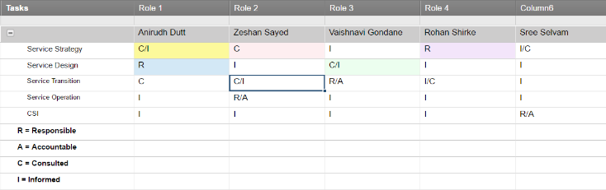

**Fig 10. RACI Matrix 1**

The second phase involved researching on the issues faced by Rainbow Cleaning Solutions and coming up with viable solutions using ITIL standards. Responsibilities and the areas covered by individual project members are displayed as below using the RACI format.

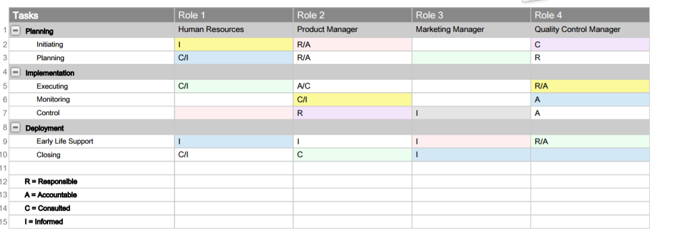

**Fig 11. RACI Matrix 2**

# AUTHORS

1. Rohan Shirke, Illinois Institute of Technology, 3300 S Federal St, Chicago, IL – 60616.
2. SreeKumar Selvam, Illinois Institute of Technology, 3300 S Federal St, Chicago, IL – 60616.